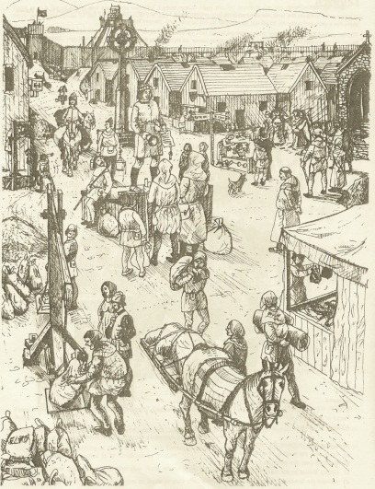
S1 Homework
Imagine you have travelled back in time to Medieval Scotland and found yourself standing in the street of a town Your task is to describe what you can see, smell and hear all around you
Success Criteria
- You should write between half a page to a page

- You should mention as many of the following words as possible -
- Mercat Cross (what it is and what's going on around it)
- The tron
- Town crier
- Punishments
- Jobs

- You should also mention smells and sounds!

