Navigation

Explorers in the 16th century had to be good navigators. They did not have modern day electronic navigational devices. They kept records of their voyages in a portalano, which was a combination of a chart and a diary. It contained compass directions, tide flows, depths and other useful information. Many of these portalanos still exist today.
It was a common sight to see cartographers, or map makers, waiting for ships to return from long journeys so that they could bring their maps up to date. But, as you can imagine, many captains preferred to keep this information to themselves. Why?
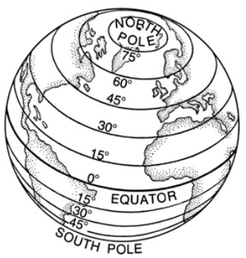
When on land it is fairly easy to find your way about. However at sea it can be very difficult. The surface of the sea looks the same and you can’t ask a police officer! The only time sailors could really tell where they were was when they were near land that they recognised. Details of landmarks such as large rocks, mountain peaks and bays would be recorded in a captain's portalano. In shallow water the sailors would use a lead to sound the bottom of the seabed. A lead weight attached to a rope was thrown overboard. The bottom of the weight was smeared with tallow (animal fat). When it was pulled up, some of the seabed – mud, pebbles, shells, etc would stick to the tallow. An experienced navigator would know when land was near by looking at the depth of the water and what was on the seabed.

However, the early explorers were usually in waters that they did not know, or where the water was too deep. In cases like that they had to work out their position using other means, e.g. using lines of latitude (imaginary lines around the Earth) and the position of the sun and the stars. Because of the Earth’s spin, the stars appear to travel across the night sky. Only the North Star remains fixed. This makes it extremely helpful to navigators as whatever angle the North Star was above the horizon was a measure of the ship’s latitude.

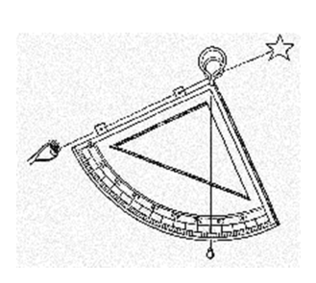
The picture on the left is a quadrant. A sailor would see the North Star along one edge, and where the string fell would tell approximately the ship’s latitude.

The speed of the ship was calculated by attaching a wooden float to a line - known as the "logline" - where knots were tied at measured intervals of 47 feet 3 inches (14.4018 m). When the wooden float was tossed overboard, the speed was calculated by counting the number of knots that slipped through the fingers of the sailor holding the logline over 30 seconds.

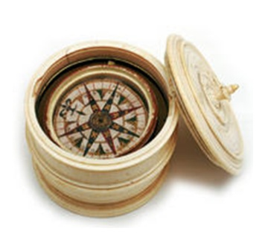
Most ships were equipped with a magnetic compass that was kept on deck and could be illuminated at night by means of a lamp burning olive oil. Although the compass was in wide use, most captains did not know why its needle pointed north. In fact, many captains preferred to keep the existence of a compass on board secret because superstitious crew members would think that the ship was being guided by sinister forces.

Task
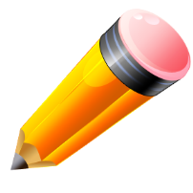
Create a booklet to teach people about navigation on ships during the voyages of discovery. You should include information on the following -
Writing in a Portalano
- Describe what a Portalano was
- Explain how it helped explorers navigate

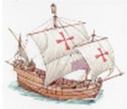
Using the migration of birds
- Describe the migration of birds
- Explain how the migration of birds helped explorers.

Using a lead
- Describe what a lead was
- Explain how it was used

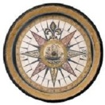
Using the Sun and Stars
- Describe the position of the North Star
- Explain how the quadrant helped to identify latitude

Using a Compass
- Describe what a compass is
- Explain how they helped explorers navigate

Working out Speed and Distance
- Describe what a logline was
- Explain how a logline helped explorers worked out speed and distance.

If you could only use one method of navigation which would it be? How would you justify your answer?

